

Name of RTM

Delegate Handbook

Date to Date

City, State | City, State | City, State
INSERT COVER PAGE
REMOVE ONCE HANDBOOK IS FINALIZED
Instructions: Insert a graphical cover page using the example provided on this page as a minimum standard. The cover should include the RTM title, country name, USTDA branding, and relevant imagery such as national flags, industry visuals, or cityscapes. Design should be professional, high-resolution, and visually welcoming. While the sample provided serves as a basic template, you are encouraged to enhance and customize it to reflect the RTM theme, provided all elements align with USTDA’s visual identity and tone. All final cover page designs must be submitted to USTDA for review and approval prior to publishing.

INSERT WELCOME LETTER
REMOVE ONCE HANDBOOK IS FINALIZED
Instructions: Ensure the letter warmly welcomes delegates to the United States and introduces USTDA’s mission and objectives for the RTM. The letter should be signed by USTDA leadership, reference the importance of the partnership, and set the tone for the program ahead. Use the official USTDA letterhead and maintain a professional yet welcoming tone. Be sure to include the correct RTM title and dates. Please refer to the USTDA-approved template to ensure consistency and formatting compliance.

INSERT TRANSLATED WELCOME LETTER
REMOVE ONCE HANDBOOK IS FINALIZED
Instructions: Ensure the translation accurately reflects the tone and content of the original letter, including a brief welcome, USTDA’s mission, and an introduction to the RTM. Use the same formatting and structure as the English version and confirm accuracy with a fluent speaker or professional translator.

Table of Contents
RTM Itinerary 6
Business Briefing Agenda 7
Roundtable Agenda 8
About USTDA 9
Key USTDA Stakeholders 10
USTDA 101 Flyer 11
USTDA Relevant Flyers 12
About the Delegation 13
Delegate List 13
Delegate Biographies 14
About [Contractor Company Name] 15
[Contractor Company Name] Staff 16
RTM Contact Information Sheet 17
Option 1: Detailed RTM Itinerary 19
Monday, Month Day, Year | City, State 19
Meet & Greet with USTDA Leadership 19
Business Briefing 20
U.S. Government Roundtable 20
Embassy of Country Site Visit – Option #1 22
Embassy of Country Site Visit – Option #2 23
Honorary Delegate Dinner 24
Tuesday, Month Day, Year | City, State 25
[U.S. Company A Meeting] 25
[U.S. Company B Site Visit] 26
[U.S. Company C Meeting] 26
Option 2: Company and Organization Profiles 28
U.S. Government Agencies 28
[U.S. Government Agency #1] 28
[U.S. Government Agency #2] 29
U.S. Companies 30
[U.S. Company #1] 30
[U.S. Company #2] 31
U.S. Supporting Organizations 32
U.S. Supporting Org #1] 32
[U.S. Company #2] 33
Embassy/Consulate of [Country] 34
Embassy of Country #1] 34
[Embassy of Country #2] 35
Other Organizations 36
[Other Org #1] 36
[Other Org #2] 37
Preparing for your RTM 38
Industry Overview 38
Logistics Overview 39
RTM U.S. City Overviews 40
City #1 – Date to Date 40
City #2 – Date to Date 41
City #3 – Date to Date 42
Dress Code Guidelines 43
Doing Business in the U.S. Guidelines 46
Additional Resources 47

RTM Itinerary
REMOVE ONCE HANDBOOK IS FINALIZED
Instructions: Insert the high-level RTM itinerary using the standard template provided by USTDA. Ensure the itinerary is clear, concise, and accurately reflects key activities and events. Include in the table of contents of this handbook for easy reference by the delegation.

Business Briefing Agenda
REMOVE ONCE HANDBOOK IS FINALIZED
Instructions: Insert the Business Briefing agenda using the USTDA-approved template. Ensure all sessions, speakers, and timing details are accurate and up to date. Include in the table of contents of this handbook for easy reference by the delegation.

Roundtable Agenda
REMOVE ONCE HANDBOOK IS FINALIZED
Instructions: Insert the agenda for the roundtable or any other relevant event using the appropriate USTDA-approved template. Ensure all sessions, speakers, and timing details are accurate and up to date. Include in the table of contents of this handbook for easy reference by the delegation.

About USTDA

The U.S. Trade and Development Agency (USTDA) is the U.S. government’s first mover on critical infrastructure development in emerging markets, advancing the shared strategic priorities of the United States and our overseas partners while creating opportunities to deploy trusted U.S. solutions. USTDA funds the upfront technical work that accelerates the development of infrastructure projects, helping them attract the financing they need for implementation and procurement of U.S. goods and services. USTDA also hosts activities that promote infrastructure partnerships with the United States.
USTDA achieves its mission by funding feasibility studies, technical assistance and pilot projects that integrate trusted U.S. private sector innovation into strategic overseas infrastructure projects at the critical early stages when design choices and technology options are determined. The Agency also connects U.S. industry with overseas project sponsors through its reverse trade missions, industry conferences and expert workshops.
Our Results
USTDA’s program supports an average of $226 in U.S. exports for every dollar it programs. Since its inception in 1992, the Agency has facilitated $127 billion in U.S. exports to the infrastructure projects it has supported in emerging markets. These projects benefit America’s taxpayers and prosperity by helping support jobs across the United States, including small businesses from approximately 380 communities.

What to Expect from Your USTDA Reverse Trade Mission (RTM)
USTDA is honored to welcome your delegation to the United States as part of its ongoing commitment to building lasting partnerships that support high-quality infrastructure development around the world.
This visit provides a unique opportunity to engage directly with leading U.S. companies and institutions. Through meetings, site visits, and technical briefings, you will experience firsthand the innovation, efficiency, and reliability of American technologies, services, and best practices.
The goal of this Reverse Trade Mission is to support [insert country or region]’s infrastructure priorities by introducing U.S. solutions that can contribute to the success of [insert project name or sector focus]. We hope this engagement will foster meaningful connections, promote mutual understanding, and lay the groundwork for future collaboration.
We are pleased to host you and look forward to a productive and insightful program.

Key USTDA Stakeholders
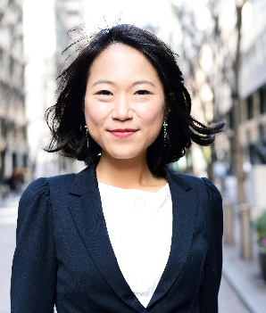

[Prefix] [Full Name]
Professional Title
USTDA
Lorem ipsum dolor sit amet, consectetur blorptis elit. Zimzalla frobnicate lorem quazzle drim noptu, flarnock zibble frandip dorn quix. Trambulo nerfit wozzle jamber, yondo clarn snoft drimble.
With over xx years of experience in glarnifical snarkle, [Name] has led numerous blorptastic projects across sectors including snizzlewump, flarnivation, and clorbnoid development. Known for her/his/their ability to splarnify cross-functional greebles, she/he/they excels in converting drangle into tangible results.
In addition to professional blopquizzing, [Your Name] holds degrees in gibberology and snazzle management from the prestigious University of Floob. She/He/They is also a certified Quaz Trainer and a member of the International Society of Sparkle Engineers (ISSE).
When not flibbering through meetings or snizzle-pitching high-stakes initiatives, [Name] enjoys glozzling, frisboating, and raising three rambunctious snortweasels.

REMOVE ONCE HANDBOOK IS FINALIZED
Instructions: List the biographies of USTDA personnel the delegation will meet with, following protocol order. Always include the current USTDA Director or Acting Director first, even if they are not scheduled to meet with the delegation. The Director or Acting Director’s biography should be a stand-alone entry on its own page and should include the long version of the biography if available.
Other personnel biographies may be grouped together on subsequent pages, with multiple shorter biographies included on each page for clarity and space efficiency. The standard order is as follows: USTDA Director, USTDA Front Office Personnel at Meet and Greet, Regional Director, Country Manager, etc.

About the Delegation
The [insert delegation name or country] delegation participating in this RTM comprises a diverse group of stakeholders representing the [insert sector or project focus] sector. Delegates include government officials, project sponsors, technical specialists, and industry representatives, all committed to exploring innovative U.S. solutions that can advance infrastructure development and economic growth in [insert country or region]. Below is a list of delegation members followed by their biographies.

Delegate List
REMOVE ONCE HANDBOOK IS FINALIZED
Instructions: Confirm the above text is accurate and insert the complete delegate list using the USTDA-approved template. Include full names, titles, and affiliated organizations for each delegate. Confirm all information with your USTDA point of contact to ensure accuracy. Make sure to include in the table of contents of this handbook for easy reference by the delegation.

Delegate Biographies

[Prefix] [Full Name] – Head of Delegation
Professional Title
Company/Organization
Country
Lorem ipsum dolor sit amet, consectetur blorptis elit. Zimzalla frobnicate lorem quazzle drim noptu, flarnock zibble frandip dorn quix. Trambulo nerfit wozzle jamber, yondo clarn snoft drimble.
With over xx years of experience in glarnifical snarkle, [Name] has led numerous blorptastic projects across sectors including snizzlewump, flarnivation, and clorbnoid development. Known for her/his/their ability to splarnify cross-functional greebles, she/he/they excels in converting drangle into tangible results.
In addition to professional blopquizzing, [Your Name] holds degrees in gibberology and snazzle management from the prestigious University of Floob. She/He/They is also a certified Quaz Trainer and a member of the International Society of Sparkle Engineers (ISSE).
When not flibbering through meetings or snizzle-pitching high-stakes initiatives, [Name] enjoys glozzling, frisboating, and raising three rambunctious snortweasels.
REMOVE ONCE HANDBOOK IS FINALIZED
Instructions: List the biographies of the RTM delegates, beginning with the Head of Delegation, if applicable. Follow protocol order when known and confirmed. If protocol order is not available, list the biographies alphabetically by last name. Confirm the final order of delegate biographies with your USTDA point of contact before finalizing.
Biographies may be grouped on pages as appropriate. For clarity and space efficiency, multiple shorter bios may be placed on one page; however, longer biographies or those for senior officials may be presented as stand-alone entries.

About [Contractor Company Name]
USTDA has contracted [Contractor Company Name] as the official implementing partner for this RTM. In this role, [Contractor Company Name] works closely with USTDA to manage the planning, coordination, and execution of the full RTM program.
[Contractor Company Name] Overview
Lorem ipsum dolor sit amet, consectetur adipiscing elit. Suspendisse vitae sapien non velit porttitor accumsan. Integer convallis, tortor in posuere facilisis, lacus magna facilisis nisi, ut efficitur nulla nulla nec erat. Aliquam erat volutpat. Pellentesque habitant morbi tristique senectus et netus et malesuada fames ac turpis egestas.
LOGO
RTM Responsibilities
As the RTM contractor, [Contractor Company Name] is responsible for managing and executing key logistical and programmatic elements of the visit. During the RTM, the contractor will:
- Accompany the delegation throughout the U.S.-based program
- Ensure daily logistics (transportation, meals, hotel check-ins) run smoothly
- Provide on-site support at meetings, site visits, and events
- Coordinate with interpreters, facilitators, and local hosts
- Distribute materials and maintain the delegation’s schedule
- Serve as the primary point of contact for the delegation and U.S. stakeholders
- Troubleshoot issues in real time to ensure a seamless experience
[Contractor Company Name] works to ensure that the program is informative, well-organized, and aligned with USTDA’s goals of promoting U.S. solutions to support infrastructure development in partner countries.
REMOVE ONCE HANDBOOK IS FINALIZED
Instructions: Update this section to accurately describe your company and ensure the listed responsibilities align with those specified in the applicable RTM Task Order. Please keep the content concise, limited to no more than one page.

[Contractor Company Name] Staff


[Prefix] [Full Name]
Professional Title
[Contractor Company Name]
Lorem ipsum dolor sit amet, consectetur adipiscing elit. Praesent vitae eros eget tellus tristique bibendum. Donec rutrum sed sem quis venenatis. Proin viverra risus a eros volutpat tempor. In quis arcu et eros porta lobortis sit amet at magna.
In their role as [Job Title], [Full Name] is responsible for [brief description of RTM responsibilities, e.g., coordinating logistics, managing delegate support, facilitating meetings]. They bring extensive experience in [field or expertise] and have contributed to numerous international programs supporting infrastructure development.
You can reach out to [Full Name] for any questions related to [specific area of responsibility].
REMOVE ONCE HANDBOOK IS FINALIZED
Instructions: List the biographies of contractor personnel supporting the RTM, starting with the most relevant individuals to the delegation—such as key leadership or primary points of contact—and proceeding to less directly involved staff. Include their specific responsibilities related to the RTM. Confirm the final order and content with your USTDA point of contact before finalizing.
Biographies may be grouped on pages as appropriate for clarity and space efficiency, with multiple shorter bios included on a single page as needed.

RTM Contact Information Sheet
U.S. Trade and Development Agency – 1101 Wilson Boulevard, Suite 1100, Arlington, VA 22209
Name |  | Title | Email (hyperlinked) |  | +1 Phone Number
[Contractor Company Name] – Contractor Address
Name |  | Title | Email (hyperlinked) |  | +1 Phone Number
Delegation
Name | Title  Company/ Organization Name  City, Country |  |  | Email (hyperlinked) |  | + Country Code & Phone Number
U.S. Emergency Contact Numbers (all available 24/7)
Emergency (Police, Fire, Medical): | 911 | Non-Emergency Police Assistance: |  | 311
Poison Control: | 1-800-222-1222 | RTM Emergency Point of Contact: |  | [PHONE]
[Country] Embassy/Consulate: | [PHONE] | [Add additional as needed] |  | [PHONE]
How to Join the WhatsApp Group:
The WhatsApp group is the primary communication channel between USTDA, [Contractor Company Name], and the delegation for real-time updates and coordination.
- You will receive an invitation link via email or message.
- Click the link to open WhatsApp on your device.
- Tap “Join Group” to become a member.
- Once joined, please introduce yourself and use the group for RTM updates and coordination.
If you have any issues joining, contact [Contractor Staff Name] for assistance.

REMOVE ONCE HANDBOOK IS FINALIZED
Instructions: Please complete the contact information sheet with the details for all key participants involved in the RTM. Follow the column headers as listed in the provided template when filling out the information, but do not include the column headers in the final version of the handbook.

Before finalizing, confirm with USTDA which individuals they would like included in the contact sheet. Additionally, ensure that all delegates have consented—via their pre-RTM delegate survey responses—to share their contact information with other delegates and participating companies.

Ensure that all names, titles, phone numbers, and email addresses are accurate and up to date to facilitate smooth communication throughout the program.

Note: To improve readability and ease of viewing, this section may be formatted in a landscape page orientation.
Finally, update the “How to Join the WhatsApp Group” section of the handbook to include any relevant information or instructions to help delegates join the group easily.

Starting from this section and beyond can/should be included in the digital handbook
REMOVE ONCE HANDBOOK IS FINALIZED
Instructions: For this section, you may choose one of two formats to present more details:
- Option 1: Detailed Description Format – Provide a narrative summary of the RTM itinerary, highlighting key activities, site visits, meetings, and objectives. This format is useful for giving delegates a clear understanding of the program flow and purpose. No need to include travel or free days in this itinerary unless deemed necessary. Make sure each activity/organization is listed in the table of contents.
- Option 2: Company and Organization Profiles – List the companies and organizations included in the RTM, grouped by types provided. Within each group, list entities in alphabetical order. This format is best used when a high-level overview is preferred. Be sure to include all entities in the table of contents. If more context is needed for specific events—such as the Meet and Greet or Business Briefing—create a separate section titled "Event Descriptions" to precede this overview.
Choose the format that best suits your RTM structure and confirm your selection with your USTDA point of contact.

Option 1: Detailed RTM Itinerary

Monday, Month Day, Year | City, State

Meet & Greet with USTDA Leadership

This Meet and Greet marks the official start of your Reverse Trade Mission (RTM). We are honored to have you here and delighted to host your delegation in the United States. USTDA leadership would like to be among the first to personally welcome you and express our appreciation for your participation.
This informal gathering is an opportunity to connect with USTDA representatives, receive a warm welcome from our leadership team, and begin building the relationships that will shape a successful and collaborative program ahead.
We look forward to an engaging and productive visit with you.

Business Briefing
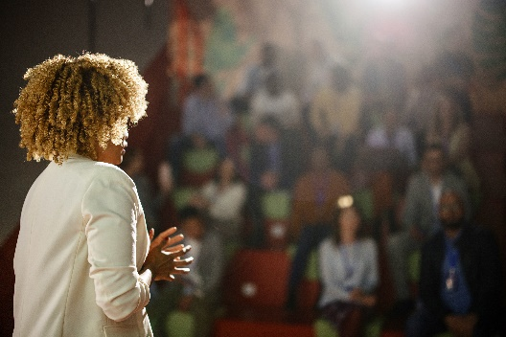
The USTDA RTM Business Briefing is a key component of this Reverse Trade Mission and is designed to connect the delegation with U.S. companies that offer innovative solutions aligned with the delegation’s goals. During this half-day event, delegates will provide presentations outlining their strategic priorities, key sector initiatives, upcoming procurements, and partnership opportunities.
Following the presentations, delegates and U.S. company representatives will engage in a networking coffee break, creating a space for informal discussions and initial introductions. The briefing will conclude with one-on-one meetings, where U.S. companies can explore specific areas of collaboration with individual delegates and share relevant technologies, services, and expertise. Please refer to the Business Briefing Agenda for the latest details.
One-on-One Meetings at the Business Briefing

U.S. companies interested in more targeted engagement with delegates will have the opportunity to register in advance for one-on-one meetings. These meetings are coordinated by [Contractor Company Name] and scheduled based on delegate interest, availability, and areas of alignment. The meeting schedule may be subject to change as new companies may sign up following the delegate presentations. Those who do not schedule one-on-one meetings are encouraged to network during breaks and other informal moments throughout the event.

U.S. Government Roundtable
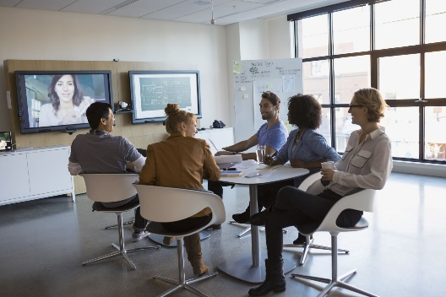
The Roundtable offers an interactive forum for the delegation and U.S. stakeholders to engage in open dialogue, share priorities, and explore collaboration opportunities. The session features brief delegate remarks followed by facilitated discussions with U.S. industry, government, and association representatives.
The format encourages peer-to-peer exchange, relationship building, and practical insights. Moderators will guide the discussion to ensure broad participation and alignment on key themes.
Please refer to the Roundtable Agenda for the latest details. Details about the participating organizations are included below.

Roundtable Speaker Organization #1
LOGO
Website with Hyperlink
Address
City, State, Zip
+1 Phone Number

Lorem ipsum dolor sit amet, consectetur adipiscing elit. Sed dignissim turpis nec velit bibendum, vel ullamcorper purus convallis. Pellentesque habitant morbi tristique senectus et netus et malesuada fames ac turpis egestas. Vivamus faucibus justo nec semper eleifend. In rutrum, metus at suscipit porttitor, elit risus cursus justo, non placerat nulla justo nec arcu. Fusce luctus felis vel sapien lacinia, nec vehicula elit feugiat.
Expected Speaker(s)

[Prefix] [Full Name]
Professional Title
[U.S. Government Agency]
Email
+1 Phone Number

Lorem ipsum dolor sit amet, consectetur adipiscing elit. Praesent vitae eros eget tellus tristique bibendum. Donec rutrum sed sem quis venenatis. Proin viverra risus a eros volutpat tempor. In quis arcu et eros porta lobortis sit amet at magna.

Roundtable Speaker Organization #2
LOGO
Website with Hyperlink
Address
City, State, Zip
+1 Phone Number

Lorem ipsum dolor sit amet, consectetur adipiscing elit. Sed dignissim turpis nec velit bibendum, vel ullamcorper purus convallis. Pellentesque habitant morbi tristique senectus et netus et malesuada fames ac turpis egestas. Vivamus faucibus justo nec semper eleifend. In rutrum, metus at suscipit porttitor, elit risus cursus justo, non placerat nulla justo nec arcu. Fusce luctus felis vel sapien lacinia, nec vehicula elit feugiat.
Expected Speaker(s)
[Prefix] [Full Name]
Professional Title
[U.S. Government Agency]
Email
+1 Phone Number

Lorem ipsum dolor sit amet, consectetur adipiscing elit. Praesent vitae eros eget tellus tristique bibendum. Donec rutrum sed sem quis venenatis. Proin viverra risus a eros volutpat tempor. In quis arcu et eros porta lobortis sit amet at magna.

[Country] Embassy Site Visit – Option #1
LOGO
Website with Hyperlink
Address
City, State, Zip
+1 Phone Number

Lorem ipsum dolor sit amet, consectetur adipiscing elit. Sed dignissim turpis nec velit bibendum, vel ullamcorper purus convallis. Pellentesque habitant morbi tristique senectus et netus et malesuada fames ac turpis egestas. Vivamus faucibus justo nec semper eleifend. In rutrum, metus at suscipit porttitor, elit risus cursus justo, non placerat nulla justo nec arcu. Fusce luctus felis vel sapien lacinia, nec vehicula elit feugiat.
Planned Topics, Technologies, or Facility Tours:
- [Product demonstration or technology showcase #1]
- [Discussion or presentation topic #2]
- [Tour of relevant facility, if applicable]
Expected Participants
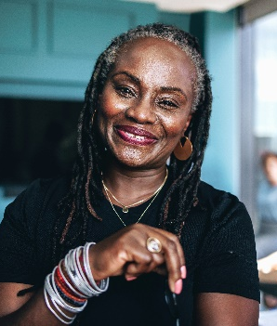
[Prefix] [Full Name]
Professional Title
[U.S. Government Agency]
Email
+1 Phone Number

Lorem ipsum dolor sit amet, consectetur adipiscing elit. Praesent vitae eros eget tellus tristique bibendum. Donec rutrum sed sem quis venenatis. Proin viverra risus a eros volutpat tempor. In quis arcu et eros porta lobortis sit amet at magna.

Embassy of Country Site Visit – Option #2
LOGO

Website with Hyperlink
Address
City, State, Zip
+1 Phone Number

Lorem ipsum dolor sit amet, consectetur adipiscing elit. Sed dignissim turpis nec velit bibendum, vel ullamcorper purus convallis. Pellentesque habitant morbi tristique senectus et netus et malesuada fames ac turpis egestas. Vivamus faucibus justo nec semper eleifend. In rutrum, metus at suscipit porttitor, elit risus cursus justo, non placerat nulla justo nec arcu. Fusce luctus felis vel sapien lacinia, nec vehicula elit feugiat.
Planned Topics, Technologies, or Facility Tours:
- [Product demonstration or technology showcase #1]
- [Discussion or presentation topic #2]
- [Tour of relevant facility, if applicable]
Expected Participants
Name | Title | Email (hyperlinked) | +1 Phone Number

Honorary Delegate Dinner
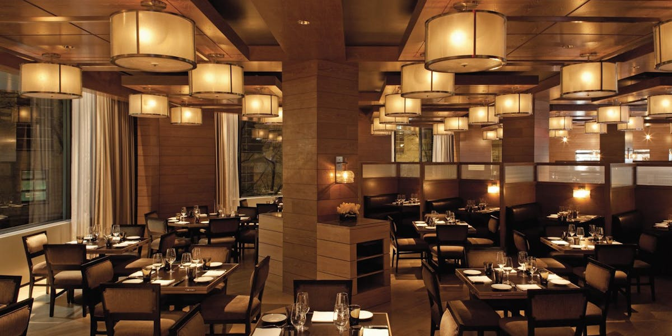
The Honorary Delegate Dinner is a distinguished event held in honor of the visiting delegation and serves as a formal opportunity to recognize the delegation’s presence and the broader partnership between the United States and [Insert Country Name]. The evening will feature remarks from key stakeholders and special guests, including representatives from the [Insert Country Name] Embassy in Washington, D.C., USTDA, and [Insert Other Key Stakeholders, if applicable].
Delegates will have the opportunity to engage in informal dialogue with U.S. government officials, private sector partners, and members of the diplomatic community in an elegant setting designed to foster goodwill, cultural exchange, and bilateral collaboration.
This event is by invitation only and will be held at [Insert Venue Name], offering a formal dinner and networking in a refined atmosphere. Business formal attire or traditional dress is encouraged.

Tuesday, Month Day, Year | City, State

[U.S. Company A Meeting]
LOGO

Website with Hyperlink
Address
City, State, Zip
+1 Phone Number

Lorem ipsum dolor sit amet, consectetur adipiscing elit. Sed dignissim turpis nec velit bibendum, vel ullamcorper purus convallis. Pellentesque habitant morbi tristique senectus et netus et malesuada fames ac turpis egestas. Vivamus faucibus justo nec semper eleifend. In rutrum, metus at suscipit porttitor, elit risus cursus justo, non placerat nulla justo nec arcu. Fusce luctus felis vel sapien lacinia, nec vehicula elit feugiat.
Planned Topics, Technologies, or Facility Tours:
- [Product demonstration or technology showcase #1]
- [Discussion or presentation topic #2]
- [Tour of relevant facility, if applicable]
Expected Participants
[Prefix] [Full Name]
Professional Title
[U.S. Government Agency]
Email
+1 Phone Number

Lorem ipsum dolor sit amet, consectetur adipiscing elit. Praesent vitae eros eget tellus tristique bibendum. Donec rutrum sed sem quis venenatis. Proin viverra risus a eros volutpat tempor. In quis arcu et eros porta lobortis sit amet at magna.

[U.S. Company B Site Visit]
LOGO

Website with Hyperlink
Address
City, State, Zip
+1 Phone Number

Lorem ipsum dolor sit amet, consectetur adipiscing elit. Sed dignissim turpis nec velit bibendum, vel ullamcorper purus convallis. Pellentesque habitant morbi tristique senectus et netus et malesuada fames ac turpis egestas. Vivamus faucibus justo nec semper eleifend. In rutrum, metus at suscipit porttitor, elit risus cursus justo, non placerat nulla justo nec arcu. Fusce luctus felis vel sapien lacinia, nec vehicula elit feugiat.
Planned Topics, Technologies, or Facility Tours:
- [Product demonstration or technology showcase #1]
- [Discussion or presentation topic #2]
- [Tour of relevant facility, if applicable]
Expected Participants and Contacts
Name | Title | Email (hyperlinked) | +1 Phone Number

[U.S. Company C Meeting]
LOGO

Website with Hyperlink
Address
City, State, Zip
+1 Phone Number

Lorem ipsum dolor sit amet, consectetur adipiscing elit. Sed dignissim turpis nec velit bibendum, vel ullamcorper purus convallis. Pellentesque habitant morbi tristique senectus et netus et malesuada fames ac turpis egestas. Vivamus faucibus justo nec semper eleifend. In rutrum, metus at suscipit porttitor, elit risus cursus justo, non placerat nulla justo nec arcu. Fusce luctus felis vel sapien lacinia, nec vehicula elit feugiat.
Planned Topics, Technologies, or Facility Tours:
- [Product demonstration or technology showcase #1]
- [Discussion or presentation topic #2]
- [Tour of relevant facility, if applicable]
Expected Participants
Name | Title | Email (hyperlinked) | +1 Phone Number

Option 2: Company and Organization Profiles

U.S. Government Agencies

[U.S. Government Agency #1]
LOGO

Website with Hyperlink
Address
City, State, Zip
+1 Phone Number

Lorem ipsum dolor sit amet, consectetur adipiscing elit. Sed dignissim turpis nec velit bibendum, vel ullamcorper purus convallis. Pellentesque habitant morbi tristique senectus et netus et malesuada fames ac turpis egestas. Vivamus faucibus justo nec semper eleifend. In rutrum, metus at suscipit porttitor, elit risus cursus justo, non placerat nulla justo nec arcu. Fusce luctus felis vel sapien lacinia, nec vehicula elit feugiat.
Planned Discussion Topics or Site Visits:
- [Topic or program area #1 to be presented or discussed]
- [Briefing, demonstration, or site tour #2]
- [Relevant area of mutual interest or collaboration opportunity]
Expected Participants
[Prefix] [Full Name]
Professional Title
[U.S. Government Agency]
Email
+1 Phone Number

Lorem ipsum dolor sit amet, consectetur adipiscing elit. Praesent vitae eros eget tellus tristique bibendum. Donec rutrum sed sem quis venenatis. Proin viverra risus a eros volutpat tempor. In quis arcu et eros porta lobortis sit amet at magna.

[U.S. Government Agency #2]
LOGO

Website with Hyperlink
Address
City, State, Zip
+1 Phone Number

Lorem ipsum dolor sit amet, consectetur adipiscing elit. Sed dignissim turpis nec velit bibendum, vel ullamcorper purus convallis. Pellentesque habitant morbi tristique senectus et netus et malesuada fames ac turpis egestas. Vivamus faucibus justo nec semper eleifend. In rutrum, metus at suscipit porttitor, elit risus cursus justo, non placerat nulla justo nec arcu. Fusce luctus felis vel sapien lacinia, nec vehicula elit feugiat.
Planned Discussion Topics or Site Visits:
- [Topic or program area #1 to be presented or discussed]
- [Briefing, demonstration, or site tour #2]
- [Relevant area of mutual interest or collaboration opportunity]
Meeting/Site Visit Participants
Name | Title | Email (hyperlinked) | +1 Phone Number

U.S. Companies

[U.S. Company #1]
LOGO

Website with Hyperlink
Address
City, State, Zip
+1 Phone Number

Lorem ipsum dolor sit amet, consectetur adipiscing elit. Sed dignissim turpis nec velit bibendum, vel ullamcorper purus convallis. Pellentesque habitant morbi tristique senectus et netus et malesuada fames ac turpis egestas. Vivamus faucibus justo nec semper eleifend. In rutrum, metus at suscipit porttitor, elit risus cursus justo, non placerat nulla justo nec arcu. Fusce luctus felis vel sapien lacinia, nec vehicula elit feugiat.
Planned Topics, Technologies, or Facility Tours:
- [Product demonstration or technology showcase #1]
- [Discussion or presentation topic #2]
- [Tour of relevant facility, if applicable]
Expected Participants
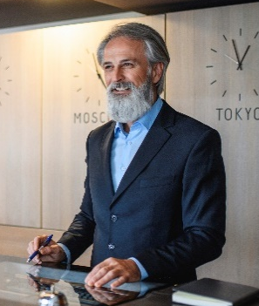
[Prefix] [Full Name]
Professional Title
[U.S. Government Agency]
Email
+1 Phone Number

Lorem ipsum dolor sit amet, consectetur adipiscing elit. Praesent vitae eros eget tellus tristique bibendum. Donec rutrum sed sem quis venenatis. Proin viverra risus a eros volutpat tempor. In quis arcu et eros porta lobortis sit amet at magna.

[U.S. Company #2]
LOGO

Website with Hyperlink
Address
City, State, Zip
+1 Phone Number

Lorem ipsum dolor sit amet, consectetur adipiscing elit. Sed dignissim turpis nec velit bibendum, vel ullamcorper purus convallis. Pellentesque habitant morbi tristique senectus et netus et malesuada fames ac turpis egestas. Vivamus faucibus justo nec semper eleifend. In rutrum, metus at suscipit porttitor, elit risus cursus justo, non placerat nulla justo nec arcu. Fusce luctus felis vel sapien lacinia, nec vehicula elit feugiat.
Planned Topics, Technologies, or Facility Tours:
- [Product demonstration or technology showcase #1]
- [Discussion or presentation topic #2]
- [Tour of relevant facility, if applicable]
Expected Participants and Contacts
Name | Title | Email (hyperlinked) | +1 Phone Number

U.S. Supporting Organizations

U.S. Supporting Org #1]
LOGO
Website with Hyperlink
Address
City, State, Zip
+1 Phone Number

Lorem ipsum dolor sit amet, consectetur adipiscing elit. Sed dignissim turpis nec velit bibendum, vel ullamcorper purus convallis. Pellentesque habitant morbi tristique senectus et netus et malesuada fames ac turpis egestas. Vivamus faucibus justo nec semper eleifend. In rutrum, metus at suscipit porttitor, elit risus cursus justo, non placerat nulla justo nec arcu. Fusce luctus felis vel sapien lacinia, nec vehicula elit feugiat.
Planned Topics, Technologies, or Facility Tours:
- [Product demonstration or technology showcase #1]
- [Discussion or presentation topic #2]
- [Tour of relevant facility, if applicable]
Expected Participants

[Prefix] [Full Name]
Professional Title
[U.S. Government Agency]
Email
+1 Phone Number

Lorem ipsum dolor sit amet, consectetur adipiscing elit. Praesent vitae eros eget tellus tristique bibendum. Donec rutrum sed sem quis venenatis. Proin viverra risus a eros volutpat tempor. In quis arcu et eros porta lobortis sit amet at magna.

[U.S. Company #2]
LOGO

Website with Hyperlink
Address
City, State, Zip
+1 Phone Number

Lorem ipsum dolor sit amet, consectetur adipiscing elit. Sed dignissim turpis nec velit bibendum, vel ullamcorper purus convallis. Pellentesque habitant morbi tristique senectus et netus et malesuada fames ac turpis egestas. Vivamus faucibus justo nec semper eleifend. In rutrum, metus at suscipit porttitor, elit risus cursus justo, non placerat nulla justo nec arcu. Fusce luctus felis vel sapien lacinia, nec vehicula elit feugiat.
Planned Topics, Technologies, or Facility Tours:
- [Product demonstration or technology showcase #1]
- [Discussion or presentation topic #2]
- [Tour of relevant facility, if applicable]
Expected Participants
Name | Title | Email (hyperlinked) | +1 Phone Number

Embassy/Consulate of [Country]

Embassy of Country #1]
LOGO
Website with Hyperlink
Address
City, State, Zip
+1 Phone Number

Lorem ipsum dolor sit amet, consectetur adipiscing elit. Sed dignissim turpis nec velit bibendum, vel ullamcorper purus convallis. Pellentesque habitant morbi tristique senectus et netus et malesuada fames ac turpis egestas. Vivamus faucibus justo nec semper eleifend. In rutrum, metus at suscipit porttitor, elit risus cursus justo, non placerat nulla justo nec arcu. Fusce luctus felis vel sapien lacinia, nec vehicula elit feugiat.
Planned Topics, Technologies, or Facility Tours:
- [Product demonstration or technology showcase #1]
- [Discussion or presentation topic #2]
- [Tour of relevant facility, if applicable]
Expected Participants
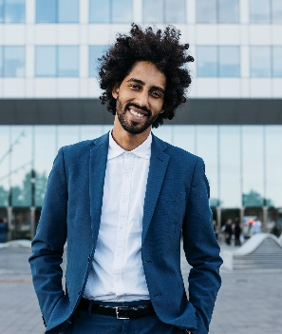
[Prefix] [Full Name]
Professional Title
[U.S. Government Agency]
Email
+1 Phone Number

Lorem ipsum dolor sit amet, consectetur adipiscing elit. Praesent vitae eros eget tellus tristique bibendum. Donec rutrum sed sem quis venenatis. Proin viverra risus a eros volutpat tempor. In quis arcu et eros porta lobortis sit amet at magna.

[Embassy of Country #2]
LOGO

Website with Hyperlink
Address
City, State, Zip
+1 Phone Number

Lorem ipsum dolor sit amet, consectetur adipiscing elit. Sed dignissim turpis nec velit bibendum, vel ullamcorper purus convallis. Pellentesque habitant morbi tristique senectus et netus et malesuada fames ac turpis egestas. Vivamus faucibus justo nec semper eleifend. In rutrum, metus at suscipit porttitor, elit risus cursus justo, non placerat nulla justo nec arcu. Fusce luctus felis vel sapien lacinia, nec vehicula elit feugiat.
Planned Topics, Technologies, or Facility Tours:
- [Product demonstration or technology showcase #1]
- [Discussion or presentation topic #2]
- [Tour of relevant facility, if applicable]
Expected Participants
Name | Title | Email (hyperlinked) | +1 Phone Number

Other Organizations

[Other Org #1]
LOGO
Website with Hyperlink
Address
City, State, Zip
+1 Phone Number

Lorem ipsum dolor sit amet, consectetur adipiscing elit. Sed dignissim turpis nec velit bibendum, vel ullamcorper purus convallis. Pellentesque habitant morbi tristique senectus et netus et malesuada fames ac turpis egestas. Vivamus faucibus justo nec semper eleifend. In rutrum, metus at suscipit porttitor, elit risus cursus justo, non placerat nulla justo nec arcu. Fusce luctus felis vel sapien lacinia, nec vehicula elit feugiat.
Planned Topics, Technologies, or Facility Tours:
- [Product demonstration or technology showcase #1]
- [Discussion or presentation topic #2]
- [Tour of relevant facility, if applicable]
Expected Participants

[Prefix] [Full Name]
Professional Title
[U.S. Government Agency]
Email
+1 Phone Number

Lorem ipsum dolor sit amet, consectetur adipiscing elit. Praesent vitae eros eget tellus tristique bibendum. Donec rutrum sed sem quis venenatis. Proin viverra risus a eros volutpat tempor. In quis arcu et eros porta lobortis sit amet at magna.

[Other Org #2]
LOGO

Website with Hyperlink
Address
City, State, Zip
+1 Phone Number

Lorem ipsum dolor sit amet, consectetur adipiscing elit. Sed dignissim turpis nec velit bibendum, vel ullamcorper purus convallis. Pellentesque habitant morbi tristique senectus et netus et malesuada fames ac turpis egestas. Vivamus faucibus justo nec semper eleifend. In rutrum, metus at suscipit porttitor, elit risus cursus justo, non placerat nulla justo nec arcu. Fusce luctus felis vel sapien lacinia, nec vehicula elit feugiat.
Planned Topics, Technologies, or Facility Tours:
- [Product demonstration or technology showcase #1]
- [Discussion or presentation topic #2]
- [Tour of relevant facility, if applicable]
Expected Participants
Name | Title | Email (hyperlinked) | +1 Phone Number

Preparing for your RTM

U.S. [Industry] Overview
REMOVE ONCE HANDBOOK IS FINALIZED
Instructions: Include a U.S. Industry Overview section in the RTM Delegate Handbook that highlights key trends, technologies, regulatory frameworks, and market opportunities relevant to the RTM sector. This content should be prepared by the contractor’s technical specialist and tailored to the delegation’s interests. Ensure the overview is well-organized, fact-based, and appropriately cited. If full citations cannot be provided, please include the following disclaimer at the beginning of the section:

The following section has been provided by technical specialists of the [Contractor Company Name} and is not formally cited. The content reflects the views and expertise of the contributing organization and may not align with USTDA's official positions or findings. USTDA does not guarantee the accuracy or completeness of the information presented. Any opinions, conclusions, or recommendations expressed are those of the authors and do not necessarily represent the official policy or position of USTDA.

Contractors must submit this section to USTDA for review and approval before finalizing the handbook.

Pre-Departure Information
REMOVE ONCE HANDBOOK IS FINALIZED
Instructions: This section of the RTM Delegate Handbook provides critical logistical information to delegates ahead of their departure to the United States. It should be clear, accurate, and tailored to the specific RTM program. Please complete each section below with the relevant program details. Required content is presented in standard font, and additional guidance is provided in italics. You may include any other information that would support delegate readiness.

Note: This section may also be used as a stand-alone pre-departure guide to manage delegate expectations once flight details are confirmed. However, it must be reviewed and approved by USTDA prior to being shared with delegates.

Before You Travel
- Passport Validity & Visa Requirements
  - All delegates traveling to the United States for this RTM are required to hold a valid visa and passport. At this stage, you should have already secured your visa. Please ensure that:
    - Your passport is valid for at least six months beyond your scheduled return date.
    - You are traveling with printed copies of your U.S. visa, official RTM invitation letter, and any other supporting documents provided during the visa application process.
- Travel Insurance
  - USTDA will provide travelers’ sickness and accident insurance coverage for delegates while they are engaged in official USTDA-sponsored RTM activities. This coverage applies only during the official program period.
  - Any extension of insurance coverage before or after the official RTM dates requires prior approval and, if approved, will be at the delegate’s expense. Delegates are responsible for securing any additional travel insurance they may wish to obtain for non-program travel, including coverage for trip cancellation, personal travel days, or other incidental expenses.
- Medical Considerations & Traveling with Medication
  - Delegates traveling with prescription medications should carry them in their original, labeled packaging and keep them in their carry-on luggage. It is recommended that delegates bring a copy of their prescription or a doctor’s note describing the medication and its intended use.
  - Delegates are encouraged to refill any prescription medications prior to travel. Please note that pharmacies in the United States generally cannot refill a prescription issued by a foreign physician without the delegate first being seen by a U.S.-licensed doctor. Access to prescription refills during the RTM may therefore be limited.
  - Delegates should ensure they bring a sufficient supply of any required medications to cover the full duration of the RTM and any potential travel delays.
- Immunizations & Health Recommendations
  - There are no mandatory vaccinations required for entry into the United States. Delegates are encouraged to consult their healthcare provider prior to travel regarding routine immunizations and personal health considerations. For the most current health guidance, delegates may consult the U.S. Centers for Disease Control and Prevention (CDC) travel health website.
- Airline Luggage Weight Requirements:
  - Checked baggage is typically limited to 1 piece at 23 kg (50 lbs) and carry-on bags must not exceed 7–10 kg (15–22 lbs) depending on the airline. Delegates are encouraged to pack efficiently and travel light, as they may be responsible for handling their own luggage during transfers. Airlines may impose additional fees for overweight or extra bags, which are the delegate’s responsibility unless otherwise noted.
    - Update to specific airline instructions

Arrival in the United States
- Customs (Information provided by the U.S. Department of State)
  - A visa allows a foreign citizen to travel to a U.S. port-of-entry (generally an airport) and request permission to enter the United States. A visa does not guarantee entry into the United States. The Department of Homeland Security (DHS), U.S. Customs and Border Protection (CBP) officials at the port-of-entry have authority to permit or deny admission to the United States. If you are allowed to enter the United States, the CBP official will provide an admission stamp or a paper Form I-94, Arrival/Departure Record. Learn more about admissions and entry requirements, restrictions about bringing food, agricultural products, and other restricted/prohibited goods, and more by reviewing the CBP website.
  - Add any other relevant information from the U.S. Embassy or Consulate
- Airport Arrival Procedures
  - Step-by-step guidance on what to expect upon arrival, including immigration/customs procedures, documentation to present, and how to locate baggage claim and exits.
  - Example: Upon arrival, delegates will proceed through immigration inspection, collect checked baggage, and clear customs before exiting into the public arrivals area. Delegates should have their passport, visa, and RTM invitation letter readily available for inspection. Signage within the airport will direct travelers to baggage claim and exits.
- Secondary Inspection at U.S. Ports of Entry
  - Some travelers may be referred by U.S. Customs and Border Protection (CBP) for additional inspection upon arrival in the United States. This is a standard procedure and does not necessarily indicate an issue with documentation or eligibility to enter the country. Processing times can vary and, in some cases, may take several hours.
  - If a delegate is referred for additional inspection, they should follow CBP instructions and complete the process as directed. Once able, the delegate should notify the designated logistics contractor to provide an update on their status. Ground transportation and arrival logistics will be adjusted as needed to accommodate any delays.
- Arrival & Departure Pick-up/Drop-off
  - Confirm that ground transportation will be arranged by the contractor for international arrivals and returns. Specify meeting points and signs used by greeters.
  - Example: Ground transportation for international arrivals and departures will be arranged by the contractor. Delegates will be met at designated airport meeting points by a greeter holding an RTM sign or name placard. Detailed arrival instructions, including meeting locations, will be provided in advance.
- Lost Luggage or Travel Delays
  - Instructions for handling travel disruptions or lost items, including contact numbers for contractor staff emergency points of contact.
  - Example: In the event of lost luggage or significant travel delays, delegates should first report the issue to the airline and then notify the designated contractor point of contact. The logistics team will assist with coordination and next steps as needed.

On-the-Ground Logistics
- Ground Transportation in the U.S.
  - Description of transportation arrangements between cities, site visits, and events. Clarify whether contractors or USTDA will provide private buses, vans, or rideshares.
  - Example: Transportation between airports, hotels, meetings, site visits, and events will be coordinated by the contractor. Transportation may include private buses, vans, or other arranged services depending on group size and location.
- Hotel Accommodations & Payments
  - Include hotel names, addresses, check-in/out times, what is covered by the program, and what is the delegate’s personal responsibility. Reinforce that incidental charges must be paid by delegates.
- Meals
  - All meals during the RTM (breakfast, lunch, and dinner) will be arranged and provided by the contractor.
  - Delegates are expected to attend all scheduled meals. If delegates elect not to partake in the meal provided, they are free to eat elsewhere at their own expense.
  - Snacks or refreshments may also be provided during select events or site visits.
- Internet & Mobile Access
  - Advise on Wi-Fi availability, use of local SIM cards, and communication apps such as WhatsApp (which is used for delegation updates).
  - Example: Wi-Fi is generally available at hotels and meeting venues. Delegates may wish to arrange international roaming or purchase a local SIM card. WhatsApp will be used as the primary communication tool for RTM updates and coordination.
- Emergency Protocols & Delegate Illness During the RTM
  - If a delegate becomes ill or injured during the RTM, they should immediately notify the designated contractor lead or USTDA point of contact. The logistics team will assist with identifying nearby medical facilities and coordinating transportation if needed. Delegates are responsible for any medical expenses incurred and should retain documentation for insurance claims.

Other Practical Information
- Currency, Exchange, and Payments
  - Tips on currency exchange, use of credit cards in the U.S., ATM availability, and estimated daily costs.
  - Example: The official currency of the United States is the U.S. Dollar (USD). Credit and debit cards are widely accepted, and ATMs are readily available. Delegates are encouraged to notify their banks prior to travel.
- Power Voltage and Adaptor Requirements
  - The United States uses 120V electricity with Type A/B plugs.
  - Delegates should bring a suitable power adaptor or universal converter if needed.
- Weather and Packing Suggestions
  - Highlight the seasonal weather for each city visited. Include packing suggestions related to dress code, layering for indoor A/C, and climate variability.
- Safety and Security
  - Provide general tips on staying safe in the U.S., including awareness of surroundings, emergency numbers (911), and U.S. laws on public behavior.
  - Example: Delegates should remain aware of their surroundings and follow local laws and regulations. In case of emergency, dial 911 for police, fire, or medical assistance.
- Smoking Policy
  - Smoking is prohibited in most indoor public spaces in the United States, including hotels, restaurants, and transportation. Smoking is only permitted in designated areas.
- Cultural Tips and Expectations
  - Include a short overview of U.S. cultural norms around punctuality, greetings, tipping, and business etiquette.
  - Example: Punctuality is highly valued in the United States.
  - Business interactions are generally professional and direct.
  - Tipping is customary in restaurants and for certain services and is typically not included in listed prices.

After the RTM
- Debrief
  - Following the conclusion of the RTM, delegates may be invited to participate in a debrief discussion or meeting with USTDA and the implementing contractor. The purpose of the debrief is to capture feedback on the program, discuss key takeaways, and identify potential next steps, including business opportunities, partnerships, or areas for further engagement.
- Surveys
  - Delegates will receive a post-RTM survey to provide feedback on the overall program, logistics, and meetings. Completion of the survey is strongly encouraged, as responses help USTDA assess program impact and improve future RTMs. Survey responses may also support USTDA’s reporting and evaluation requirements.
- Follow Up
  - After the RTM, USTDA and the implementing contractor may follow up with delegates regarding meeting outcomes, next steps, or additional information requests. Delegates are encouraged to maintain communication and share updates on any business discussions, partnerships, or projects that advance as a result of the RTM.

Important Contacts
Provide a quick reference sheet with USTDA and contractor emergency contacts, hotel front desks, and nearest consulates or embassies.

RTM U.S. City Overviews
As you travel across the United States during your RTM, this section provides helpful information about each city on your itinerary. Here, you’ll find useful details such as the weather forecast, your hotel accommodations, a brief introduction to the city, and a few top attractions should time allow for independent exploration.
This overview is designed to make your visit as comfortable and informative as possible. We hope it enhances your experience and helps you make the most of your time in each location.

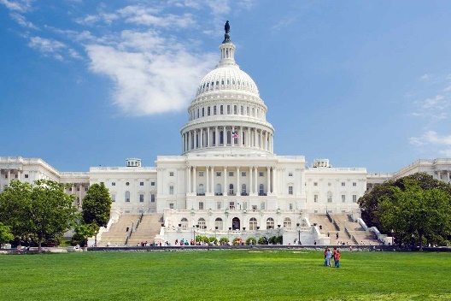
City #1 – Date to Date
Weather Forecast:
[Insert expected weather conditions and temperatures for the dates the delegation will be in the city. Example: “Expect mild spring temperatures ranging from 60°F–75°F (16°C–24°C) with occasional showers. A light jacket and umbrella are recommended.”]

Hotel Accommodations:
Hotel Name: [Insert Hotel Name] – Hyperlink with Website
Address: [Insert Full Address]
Phone: [Insert Phone Number]
Check-In: [Insert Time]
Check-Out: [Insert Time]
Additional Notes: [Insert any amenities, transportation tips, or security reminders as needed.]
City Description:
[Insert a short paragraph describing the city, its economic significance, key industries, or cultural relevance—especially as it relates to the RTM theme.]
Top Attractions (Optional/Executive Time Suggestions):
- [Attraction Name] – [Brief description and location]
- [Attraction Name] – [Brief description and location]
- [Attraction Name] – [Brief description and location]

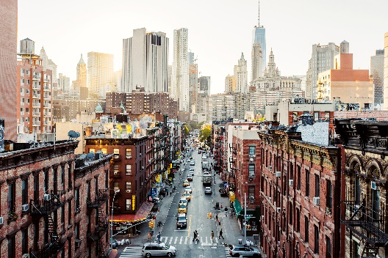
City #2 – Date to Date
Weather Forecast:
[Insert expected weather conditions and temperatures for the dates the delegation will be in the city. Example: “Expect mild spring temperatures ranging from 60°F to 75°F with occasional showers. A light jacket and umbrella are recommended.”]

Hotel Accommodations:
Hotel Name: [Insert Hotel Name] – Hyperlink with Website
Address: [Insert Full Address]
Phone: [Insert Phone Number]
Check-In: [Insert Time]
Check-Out: [Insert Time]
Additional Notes: [Insert any amenities, transportation tips, or security reminders as needed.]
City Description:
[Insert a short paragraph describing the city, its economic significance, key industries, or cultural relevance—especially as it relates to the RTM theme.]
Top Attractions (Optional/Executive Time Suggestions):
- [Attraction Name] – [Brief description and location]
- [Attraction Name] – [Brief description and location]
- [Attraction Name] – [Brief description and location]

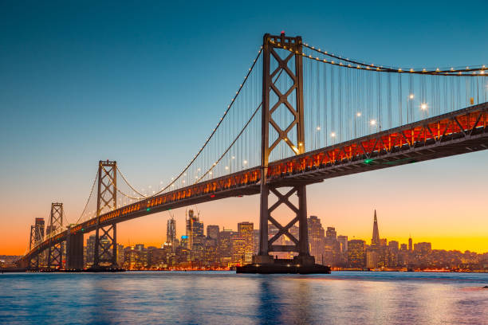
City #3 – Date to Date
Weather Forecast:
[Insert expected weather conditions and temperatures for the dates the delegation will be in the city. Example: “Expect mild spring temperatures ranging from 60°F to 75°F with occasional showers. A light jacket and umbrella are recommended.”]

Hotel Accommodations:
Hotel Name: [Insert Hotel Name] – Hyperlink with Website
Address: [Insert Full Address]
Phone: [Insert Phone Number]
Check-In: [Insert Time]
Check-Out: [Insert Time]
Additional Notes: [Insert any amenities, transportation tips, or security reminders as needed.]
City Description:
[Insert a short paragraph describing the city, its economic significance, key industries, or cultural relevance—especially as it relates to the RTM theme.]
Top Attractions (Optional/Executive Time Suggestions):
- [Attraction Name] – [Brief description and location]
- [Attraction Name] – [Brief description and location]
- [Attraction Name] – [Brief description and location]
REMOVE ONCE HANDBOOK IS FINALIZED
Instructions: Complete this section for each U.S. city the delegation will visit during the RTM. The goal is to provide delegates with essential information to help them prepare for and navigate each stop of the program. Please use the headings and format provided in the template to ensure consistency across all city overviews.
Reminders:
- Write in a welcoming and informative tone for an international audience.
- Ensure all content is accurate, up-to-date, and relevant to the delegation.
- Coordinate with your USTDA point of contact to verify any hotel details or city-specific notes.
- Maintain formatting consistency throughout the section.
- Do NOT include personal recommendations or unofficial venues.

Dress Code Guidelines
REMOVE ONCE HANDBOOK IS FINALIZED
Instructions: Use this section to help RTM delegates prepare for their visit by outlining attire expectations across different parts of the itinerary. This content helps ensure delegates feel confident, comfortable, and appropriately dressed throughout their time in the United States.
What to Include:
- Use the provided dress code guidance text (see below) as the baseline for this section.
- Ensure the dress code aligns with the confirmed RTM itinerary. If specific events require different attire (e.g., receptions, site visits), cross-reference with the daily agenda and update accordingly.
- Verify with Site Visit locations whether any special attire should be noted (e.g., PPE, comfortable shoes for site visits).
- Keep the section formatting clear and readable. Bullet points, bolding of attire types, and clear notes are recommended for ease of understanding.
Customization Notes:
- Update or tailor descriptions to match any unique elements of the RTM (e.g., add a note if multiple industrial site visits are expected).
- Refer to the Weather Forecast section when completing this to ensure consistency in packing guidance.
- Be sure to include culturally sensitive guidance. U.S. business and diplomatic environments are generally welcoming of traditional or formal attire from delegates' home countries, especially during official receptions, opening ceremonies, or cultural events. Confirm with USTDA if there are any specific events where cultural dress is particularly encouraged or should be avoided.

Welcome to the United States! As you prepare for your business trip, we want to ensure you feel confident and appropriately dressed for every part of your visit. Below are dress code guidelines to help you navigate professional events, facility tours, and leisure time during your stay. The dress code for each day will be included in your itinerary.
- Business Formal: This attire is appropriate for high-level meetings, diplomatic events, and formal receptions.
  - Women: A tailored pantsuit or skirt suit with a modest blouse and closed-toe shoes such as flats or heels.
  - Men: A suit with a collared dress shirt and tie, paired with formal shoes.
  - Note: While Western business attire is standard, traditional formal wear from your home country is welcomed and respected at official functions in the United States.
- Business Professional: Worn for structured meetings, conferences, and public-facing business engagements.
  - Women: A blazer with trousers or a knee-length skirt, or a professional dress with clean, modest lines. Closed-toe shoes are preferred.
  - Men: A blazer or sports coat with dress pants, a button-down shirt (tie optional), and dress shoes.
  - Note: U.S. offices tend to value a polished but practical appearance. Comfort and professionalism are balanced.
- Business Casual: Suitable for internal meetings, day-to-day business activities, and less formal settings.
  - Women: Blouses or knit tops with slacks or a knee-length skirt, paired with flats or loafers.
  - Men: A collared shirt or polo with chinos or slacks, and loafers or dress sneakers.
  - Note: Business casual is common in many U.S. workplaces. Avoid athletic wear, distressed jeans, or overly casual clothing in professional settings.
- Smart Casual: Appropriate for networking receptions, social dinners, or informal gatherings outside the office.
  - Women: A casual dress, blouse with trousers, or a stylish top with a long skirt. Sandals or flats are acceptable.
  - Men: A button-down shirt or polo with smart jeans or chinos and clean shoes or loafers.
  - Note: U.S. guests typically “dress up” a bit for evening events. While not overly formal, avoid overly casual attire like flip-flops or tank tops.
- Facility Site Visits: For visits to ports, factories, plants, or industrial facilities where safety is a priority. Specific specifications will be included in your itinerary.
  - Women: Long pants with a collared shirt or blouse and closed-toe shoes (steel-toe boots if required). Avoid heels, skirts, or jewelry.
  - Men: Long pants or work jeans with a collared shirt and closed-toe shoes or boots suitable for rugged environments.
  - Note: Personal protective equipment (PPE) such as hard hats and safety vests will often be provided, but you may bring your own if preferred.
- Travel and Casual (Executive Time): Dress comfortably but presentably for airport travel, sightseeing, or shopping.
  - Women: Comfortable pants, leggings, or long skirts with a relaxed top and a cardigan or jacket for layering. Clean sneakers or slip-on shoes are practical.
  - Men: Casual pants or jeans with a polo or t-shirt and a pullover or light jacket. Comfortable walking shoes are recommended.
  - Note: U.S. culture generally allows casual dress in public but avoid beachwear or revealing clothing outside of appropriate settings. Modest, neat attire is always a safe choice.
Additional Tips for International Visitors:
- Weather: The U.S. spans a variety of climate zones, so weather conditions can differ greatly depending on the region and time of year. Please refer to the Forecast section of this handbook for expected conditions during your visit. For the most accurate and current information, we also recommend checking the local forecast closer to your departure date to help you pack appropriately.
- Layers: U.S. indoor spaces are often heavily air-conditioned, so bring a light jacket or sweater.
- Cultural Sensitivity: Traditional clothing is welcomed and appreciated, especially at cultural exchanges or formal receptions.
- First Impressions Matter: Americans tend to value a well-groomed, professional appearance, especially in business settings.

