Session Coordination Guide

Thank you for accepting the invitation to participate in [Insert Event Name]. To best serve our speakers and guests, we are sharing this information and ask that you please read through the event details below.

Event Details

Date: | [Insert Date]
Event Name: | [Insert Name of Event]
Event Type: | [Insert Event Type, e.g., moderated panel, roundtable, etc.]
Location: | [Insert Location]
Event Room: | [Insert Event Room]
Time: | [Insert Time]  (Please arrive to the room [15] minutes before your session begins)
Number of Registrants: | [Insert Number of Registrants] (as of [Insert Date])

Speaker Details
- [Insert Moderator, if applicable—include title and organization]
- [Insert Speaker 1—include title and organization]
- [Insert Speaker 2—include title and organization]
- [Insert Speaker 3—include title and organization]
- [Insert additional speakers as required]

[If applicable, Audience Profile
- A brief description of who will attend (e.g., policymakers, industry leaders, students, etc.)]

Presentation Format
- Use this section to outline the high-level run of show, including event timing, flow, and tone.
- Clearly describe how the session will progress, including introductions, discussion, audience engagement, and closing remarks, as applicable.

Event Description and Objective(s)
- Use this section to provide a concise overview of the session’s purpose and focus.

Key Takeaways
- Provide key takeaways that participants should gain from this session.

Run-of-Show
- Use the below table to clearly outline the sequence of speakers, their assigned topics, and time allocations.

[Insert Start Time and End Time]
[Insert Start Time and End Time]
[Insert Start Time and End Time]
[Insert Start Time and End Time]
[Insert Start Time and End Time]
[Insert Start Time and End Time]
[Insert Start Time and End Time]

[If Applicable, Questions
- Include the key questions or discussion prompts that will guide the session.
- These may include moderator-led questions, speaker-specific prompts, or thematic discussion topics.]

Topics to Avoid
- Religious/political/racial views.
- Public policy discussions such as international trade policies and/or immigration policy.
- [If applicable, insert additional topics to avoid.]

Room Setup | 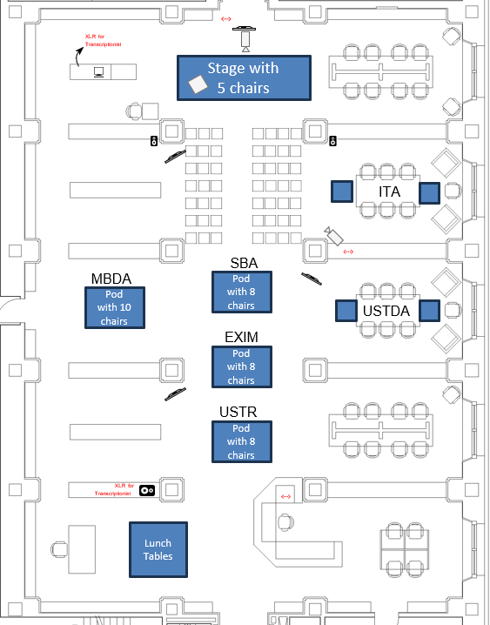
- Signage:
  - [Insert applicable information— e.g., room display, session title, logos]
- Room Setup:
- [Insert applicable information— e.g., theater, classroom, or roundtable style; include ADA accessibility, if applicable]
- Stage:
  - [Insert applicable information — e.g., chairs, tables, podium, water, name cards]
- Audio Visual:
  - [Insert applicable information — e.g., microphone number and types, screen, lighting]

[Example Room Setup]

Additional Notes
- Use this section to include any additional or special instructions here, such as directions to the event location, entrance information, and parking details.

Amplification
- Include details for social media sharing and post-event amplification.
- Event hashtag: [Insert hashtag, if applicable]
- USTDA Social Media Channels for tagging:
  - https://www.linkedin.com/company/ustda
  - https://www.twitter.com/ustda
  - https://www.instagram.com/ustda_/
  - https://www.facebook.com/ustda
- Organization 1 - Social Media Channels for tagging:
  - [Insert Social Media Handles]
- Organization 2 - Social Media Channels for tagging:
  - [Insert Social Media Handles]
- Organization 3 - Social Media Channels for tagging:
  - [Insert Social Media Handles]
- [Insert additional organizations and social media channels as required]

Event Coordinators
- Use this section to identify the key on-site personnel supporting the session, e.g. coordinators or brand ambassadors.

On-site Contact
- [Insert additional POC] M: [Insert POC’s Phone Number]

Speaker Headshots and Biographies
- Insert speaker biographies, including professional background, educational background, and a headshot.

Annex I

Email Template:

Below, please find an example email template for speakers participating in USTDA events. While the event coordination guide should be provided to speakers well in advance to outline all relevant logistics and details, this email should serve as a final reminder and a convenient reference in the days leading up to the event. These sections are recommended details that should be included, but please add any additional sections as needed.

Dear [Speaker]:

We are excited about your speaker role for [insert event name]. Here are some final logistics for this session.

Date: [Insert Date]

Location: [Insert Location]

Time: [Insert Time Range]

Arrival Instructions: [Insert arrival instructions including directions to the event location, entrance information, parking details, and specific arrival guidance, e.g., “Please arrive at the venue 15 minutes before your scheduled session.”]

Special Event Notes: [Insert any relevant notes, such as dress code, on-site registration details, etc.]

Run of Show: [Briefly outline the session structure]

Thank you and we look forward to your participation!

